ASSIGNMENT – 2

Download Dataset:- Pharma-Sales-Dataset

Challenge:- Upload the dataset to Cognos Analytics, prepare the data, explore and Create Interactive Dashboard.

Task 1:Sales by Customer.

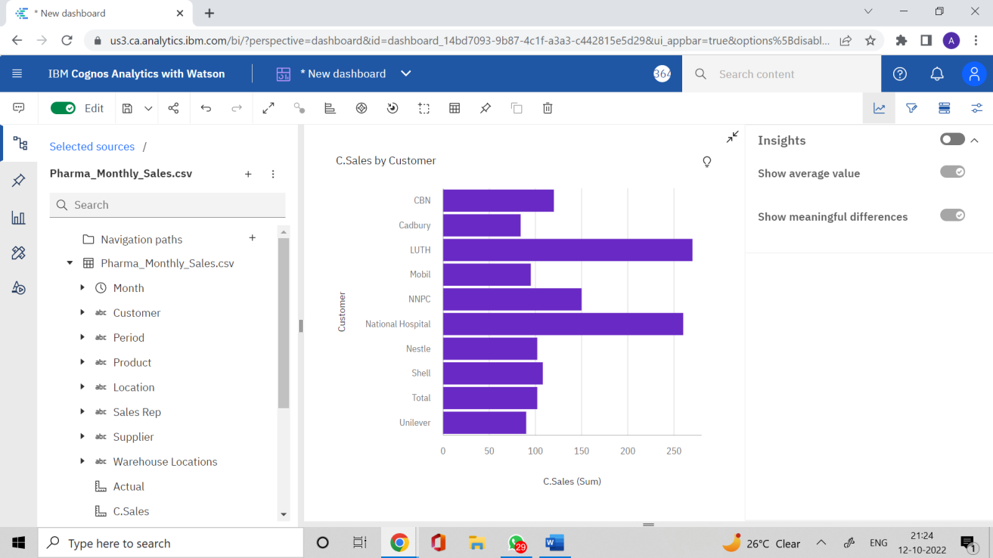

Task 2:Sales by Location.

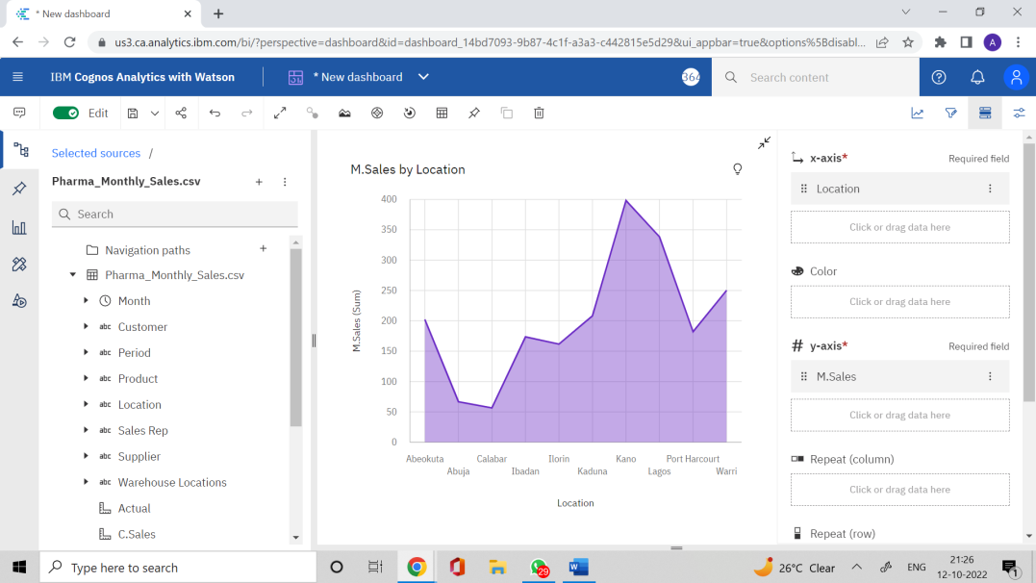

Task 3:Sales by Sales Representative.

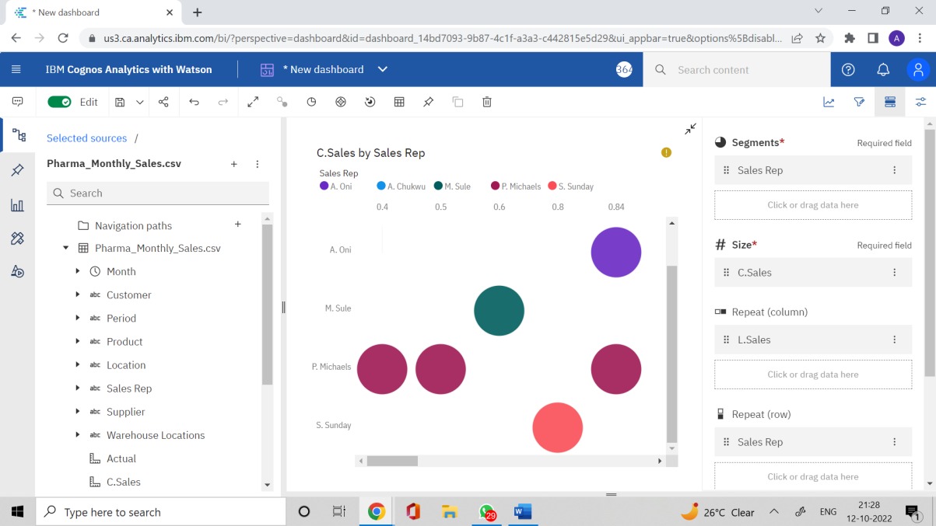

Task 4: Received Inventory from Supplier

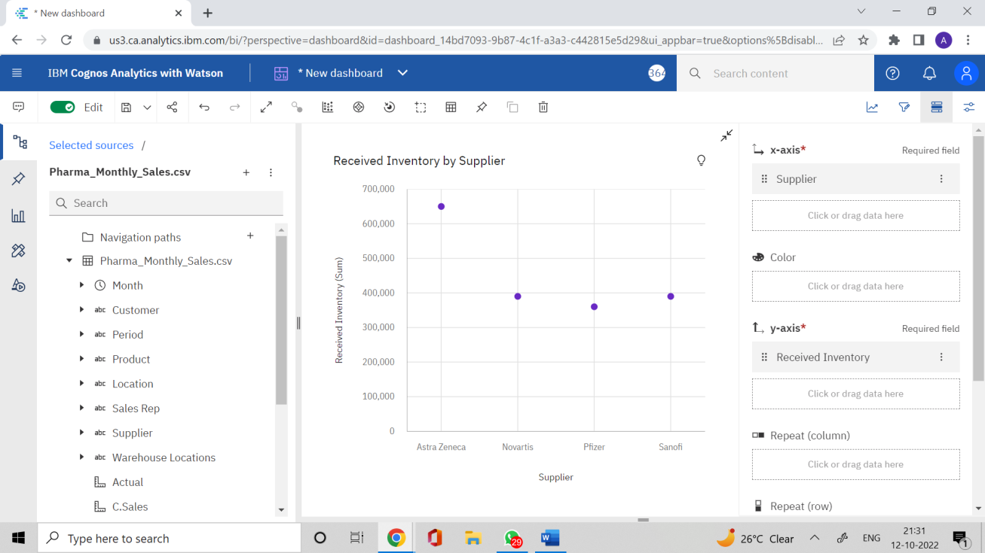

Task 5: Inventory Stock for Warehouse Locations

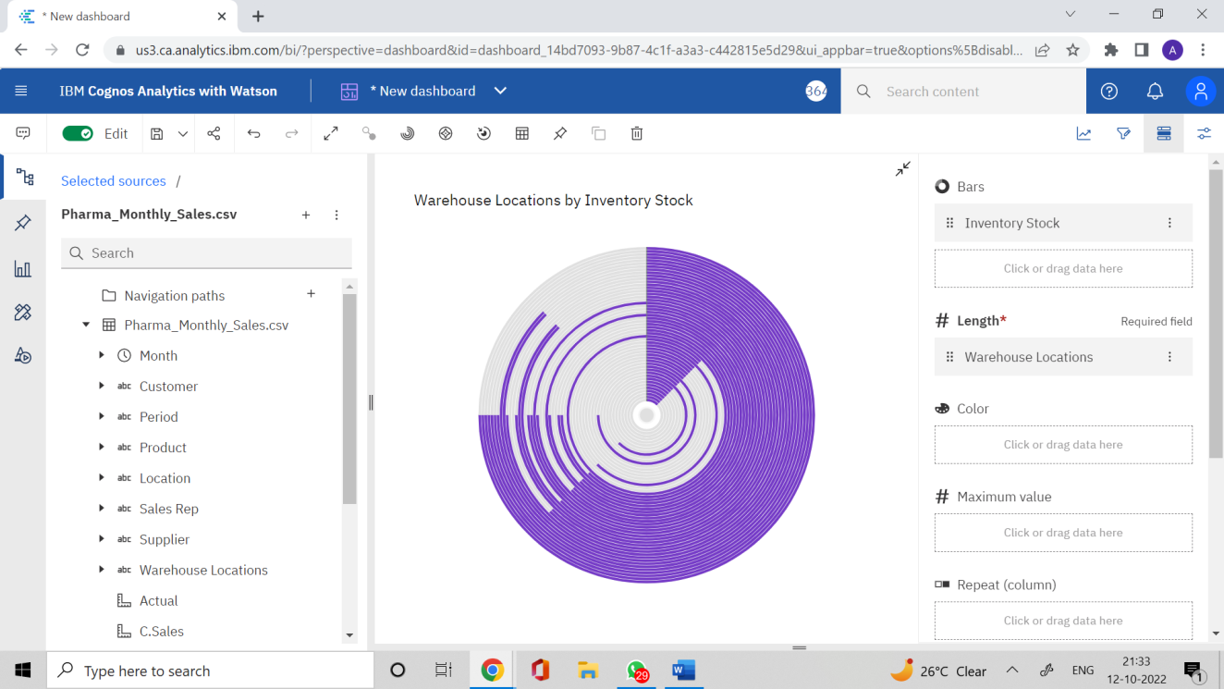

Task 6: Sales Trend

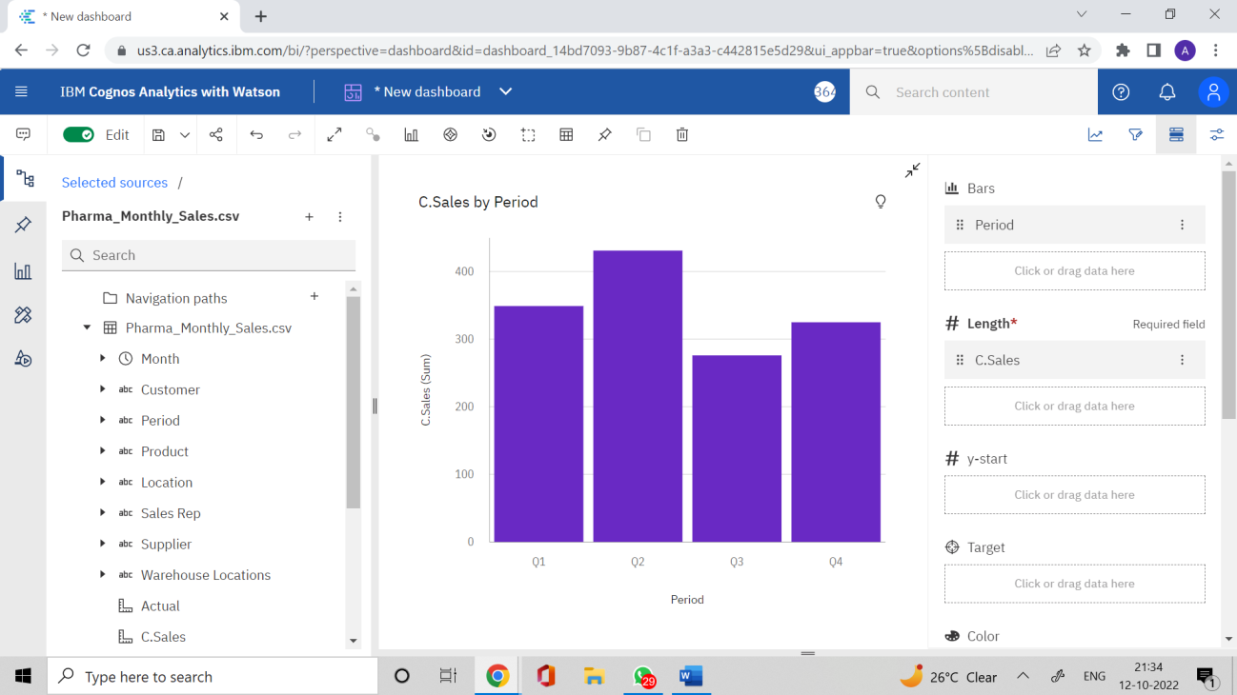

Task 7:Monthly Sales

Task 8: Actual and Received Inventory by Month

